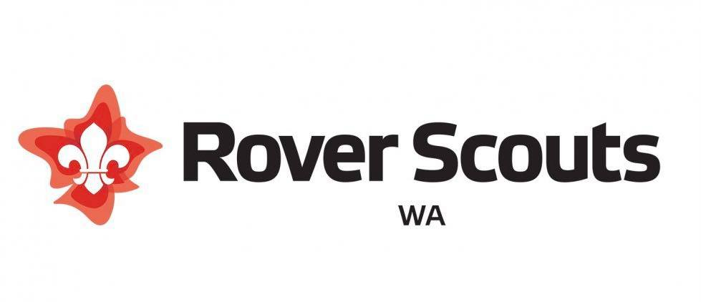
Quality Rovering Award

QRA Application
The Quality Rovering Award (QRA) is a formal recognition to Western Australian Rover Units for upholding a high standard of Rovering or ‘Quality Rovering’ over a calendar year. The QRA encompasses the requirements that Units should fulfil to run an effective Unit, through strong programming in line with the Challenge Areas and active participation in the section.
The current requirements embrace these factors to make sure that Units are providing effective development to their members and quality programming for the betterment of the section. The current update in 2021 have been made to reflect the changes to the Youth Program. The QRA was overhauled in 2007, to reflect a greater sense of community involvement, and to place greater emphasis on retention of members, and training of members. These changes are still prevalent.
All registered Western Australian Rover Units are welcome and encouraged to apply for the QRA. All applications are individually reviewed and units that have adequately met the requirements will be awarded with a QRA.
The requirements of the QRA are the following:
- Completing The QRA application form
- Submission of a Unit Logbook.
- A Unit report for the WARC Yearbook

Logbook
The Logbook serves as a visual record of the Units activities over the year. The Logbook also serves as a tool for the Unit for multiple purposes including a PR tool for future members, a source for programming ideas and a historical document of the Unit.
Logbook Requirements:
- Minimum of 6 pages (can include as many photos as desired)
- The Logbook should summarise all Unit activities from 1st of November from the previous year to the 31st of October in the current year.
- The design and delivery of the Logbook can be in any form that you would like, the more creative and comprehensive the design the more appealing it will be to readers.

Unit Report
Each Unit is required to submit a report for inclusion into the WARC yearbook. This report is a summary of what the Unit has achieved and the major highlights for the year. The submission is to be a maximum of 1 page with at least one unit photo.

Due Dates:
Applications must be submitted to the Vice Chairman- Membership and Retention by the November meeting of the Western Australian Rover Council (WARC). The QRA application form and the Logbook need to be submitted together.
The Unit Report is to be submitted to the PR Officer, by the requested date.

Submission:
QRA Application Form and Logbook: Vice Chairman- Membership and Retention: vicechairman@warovers.com.au
Unit Report: PR Officer: profficer@warovers.com.au
The WARC Executive will review the applications and the awards will be presented at the Annual Rover General Meeting in December.
If you have any questions, please contact the Vice Chairman at vicechairman@warovers.com.au
We look forward to receiving your applications and reports.

QRA APPLICATION FORM
Note: This form only fufills part of the requirements for the QRA. You will need to submit a Logbook that shows your Unit has met the rest of the criteria prescribed. Page number (no.) refers to the page number of your logbook that details the activity.
Note: To be eligible to be nominated for the ‘Unit of the Year’ Award, Units must successfully achieve the Quality Rovering Award. Achieving the Quality Rovering Award automatically ensures that the unit is nominated for the ‘Unit of the Year’ Award

Unit: ______________________________________________________________________
Year: ______________________________________________________________________
- At least one warranted Rover Adviser in the Unit, or a person acting in this role:

Name: __________________________________________________________
Contact Number: _________________________________________________

- Unit Leader to have completed Scouting Essentials Training before or during their term of office:

Name of Unit Leader: _______________________________________________
Date of course they were on: __________________________________________
Date Certificate of Proficiency (CoP) was awarded: _________________________

- Have any other members of the unit undertaken any of the following Adult Training courses during the year? (Scouting Essentials, Scouting Adventures, Scouting Leadership)

Unit Members Name | Course | Date

- What has the unit done to encourage members to undertake training?

_________________________________________________________________________________________________________________________________________________________________________________________________________________________________________________________________________________________________________________________________________________________________________________________________

- To show growth in numbers within the unit and keep a minimum standard of Rovering, list all members retained from last year and all new members to the unit.

Retained Members | New Members

- What does the unit do to encourage people to join the unit? What does the unit do to strengthen relationships with nearby Venturer Units?

______________________________________________________________________________________________________________________________________________________________________________________________________________________________________________________________________________________________________________________________________________________________________________________________________________________________________________________________________________

- Does the unit have a strong and regular participation of unit members at unit activities? What does the unit do to encourage members to participate in most activities?

☐ Yes
☐ No

___________________________________________________________________________________________________________________________________________________________________________________________________________________________________________________________________________________________________________________________________________________________________

- For metropolitan units- attendance at 85% of all possible WARC meetings, which MUST include the AGM (9 out of 11 meetings). For regional units - attendance at 45% of all possible WARC meetings (5 out of 11 meetings).
February | ☐ | August | ☐
March | ☐ | September | ☐
April | ☐ | October | ☐
May | ☐ | November | ☐
June | ☐ | December (AGM) | ☐
July | ☐

- How is your Unit contributing to the Sustainable Development Goals (SDGs) or educating members so that they are able to work towards the goals. Please provide three examples of actions taken by your Unit. (If this includes Unit activities please provide the page number in the Logbook).

___________________________________________________________________________________________________________________________________________________________________________________________________________________________________________________________________________________________________________________________________________________________________________________________________________________________________________________________________________________________________________________________________________________________

- The following Criteria should be met by listing the relevant pages in the Unit Logbook and giving brief details of the activities here.
  - At least 15 activities or outings away from the hall in the year with at least 10 NOT being a WARC run event.

Activity | Logbook Page No

  - Participation in at least one group or district event

Activity | Logbook Page No

  - At least 10 nights camping with the Units in the last year

Location | No of Nights | Logbook Page No

  - Participation in ANZAC Day (Including At-Home participation) and one other major WARC event (Sand Moot, Gravel Moot, Mission Impossible, Rover Ball, Baja etc).

Activity | Logbook Page No

  - Participation in at least two activities from each area of the Challenge Areas – Outdoor, Creative, Personal Growth and Community, with at least one community event being external to the Scout organisation.

Challenge Area | Activity | Logbook Page No
Outdoor
Creative
Personal Growth
Community

  - List any intersection activities, including at least one with the Venturer Section (not including any WARC run events)

Activity | Venturer Unit/s Involved | Logbook Page No

Proclamations

Unit
I declare that _________________________________ Rover Unit has complied with all sections of the Quality Rovering Award and believes itself to be a worthy recipient of the WA Rover Council’s Quality Rovering Award.
To the best of my knowledge all the information provided in this application is true and correct.
Signed: __________________________________________________ [Unit Leader on behalf of the unit]
Date: ___________________________________________________

WARC
To the best of my knowledge ____________________________ Rover Unit has complied with all sections of the Quality Rovering Award.
I believe that the Unit is a worthy recipient of the WA Rover Council’s Quality Rovering Award.
Signed: __________________________________________________ [WA Rover Council Chairman]
Date: ____________________________________________________

